

CHENNAI PORT AUTHORITY

PUBLIC E-AUCTION

Chennai Port will dispose of unclaimed cargoes like Boom Assembly for Kobelco Hydraulic excavator, BGR Energy System and STC First & Second Stator Halve terminal side through E-Auction on 08.06.2023. For further details log on to: www.chennaiport.gov.in or www.mstcecommerce.com

CHENNAI PORT AUTHORITY
TRAFFIC DEPARTMENT (SALES WAREHOUSE)

LIST OF CARGO COMING FOR SALE IN E-AUCTION DURING THE MONTH OF JUNE 2023

AUCTIONEER : M/s. MSTC Limited
Southern Regional Office
ISPAT BHAVAN, III Floor
5, Kodambakkam High Road,
Chennai - 600 034
www.mstcecommerce.com

INSPECTION DATE & TIME : 24.05.2023 TO 07.06.2023, except Port Holidays between 1000 Hrs. and 1600 Hrs.

E-AUCTION DATE : 08.06.2023 between 1100 Hrs. to 1630 Hrs.

TELEPHONE NOs. : 044-25312000 / 25362201
Extn.2957 / 2599 (Commercial
Division/Sales Warehouse)

Sl. No | Lot No. | Description of Cargo | No. of packages / Weight | Line No. | EMD Amount | Location
1 | 14/12 | Boom Assembly for Kobelco Hydraulic Excavator | 1 No / 2680 Kgs. | 6 | Rs.10,000/- | SQ – I
2 | 01/14 | BGR Energy system | 1 Pkg / 3720 kgs. | E/L | Rs.10,000/- | CQ lock fast
3 | 101/14 | STC First & Second Stator Halve Terminal Side | 13 Pkgs / 141899 Kgs | 1 | Rs.2,00,000/- | Back side of WQ – III shed (Road side) and WQ 3 lock fast

PHOTO IMAGE OF LOT NO. 01/14, 1 Pkg. BGR ENERGY SYSTEM
Description : Clamps – Spare parts of energy system
Weight :3720 Kgs.

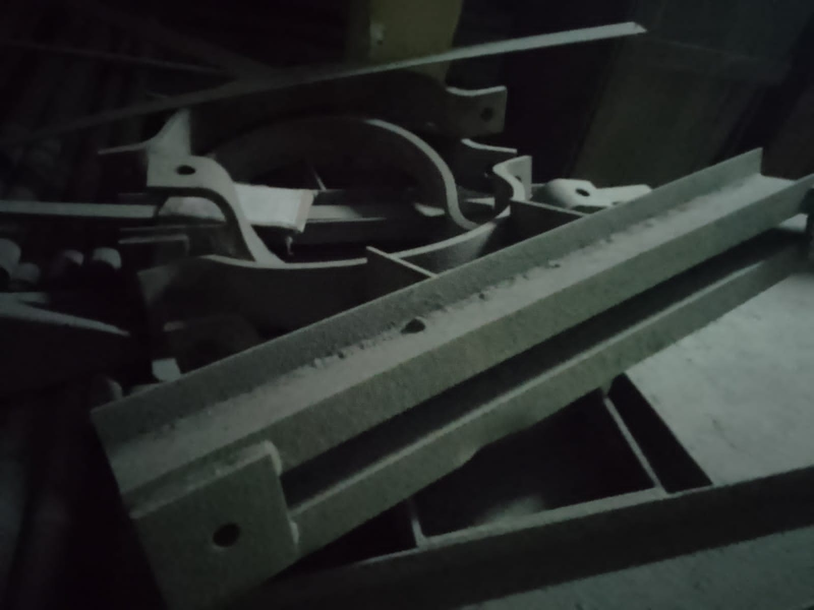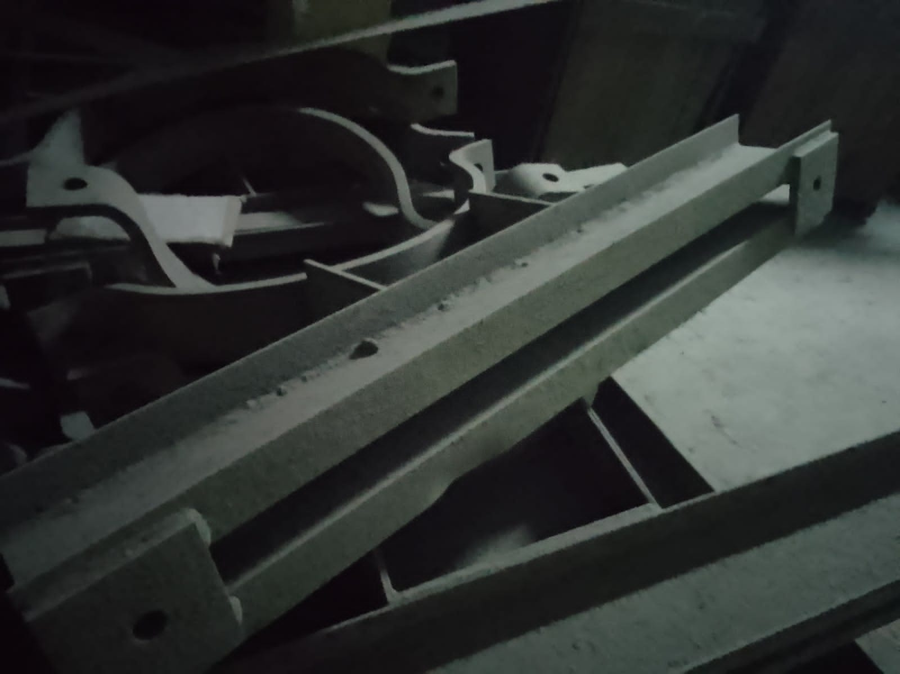

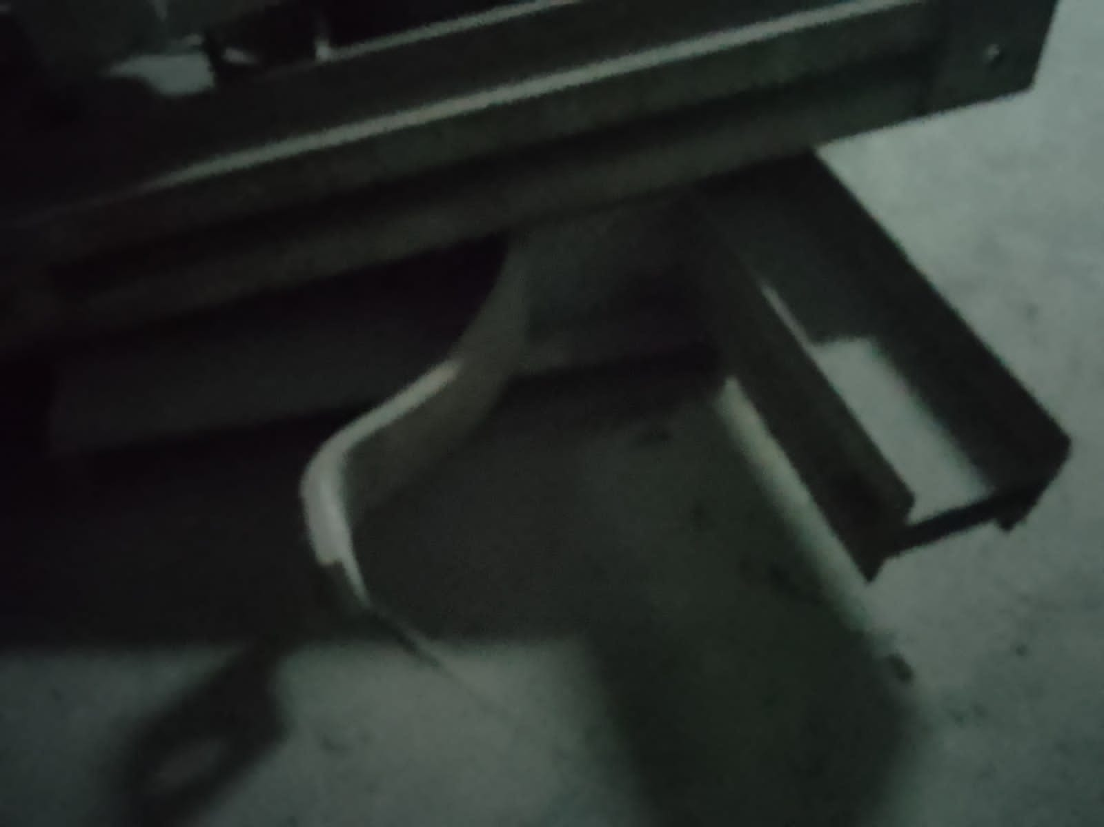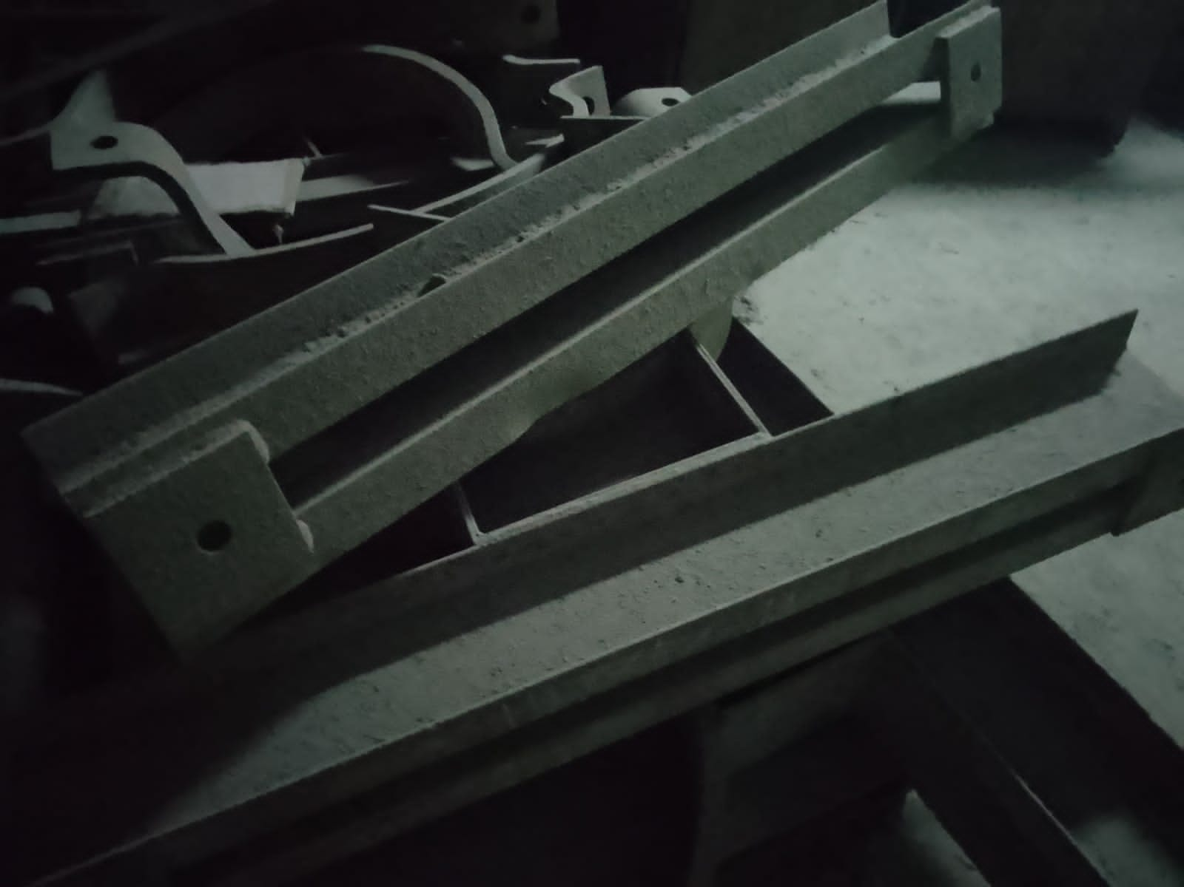

PHOTO IMAGE OF LOT No. 14/12, 1 No. BOOM ASSEMBLY FOR KOBELCO HYDRAULIC EXCAVATOR – 1 No.
Marks & Nos. :KCE-1 Boom/FOC - Chennai - Made in Japan
Weight :2680 Kgs.

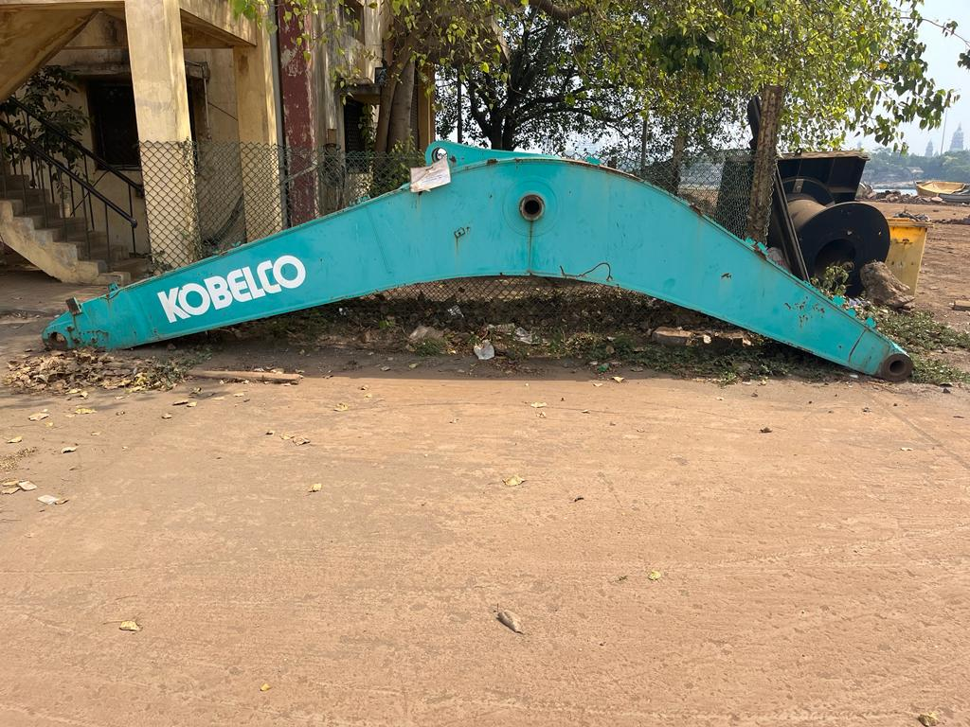

PHOTO IMAGE OF LOT No. 101/14
STC FIRST AND SECOND STATOR HALVE TERMINAL – 13 Pkgs.
Marks & Nos. : PROJECT : SRI LALITHA CEMENT TRANSPORT
LOAD PORT : ANTWERP : CONSIGNOR : ABB SWITZERLAND
Part of machinery used for generating power in the cement and other industries
Gross Weight : 141899 Kgs.
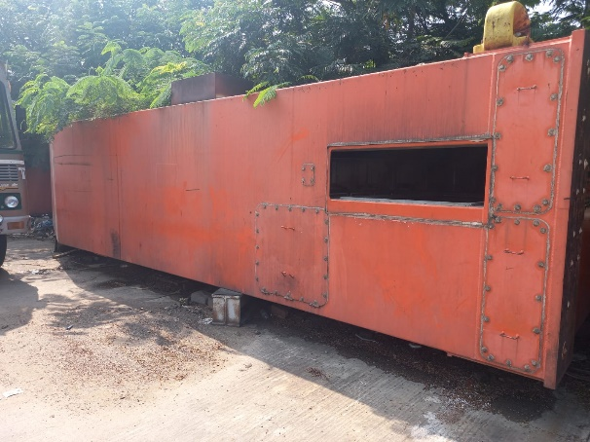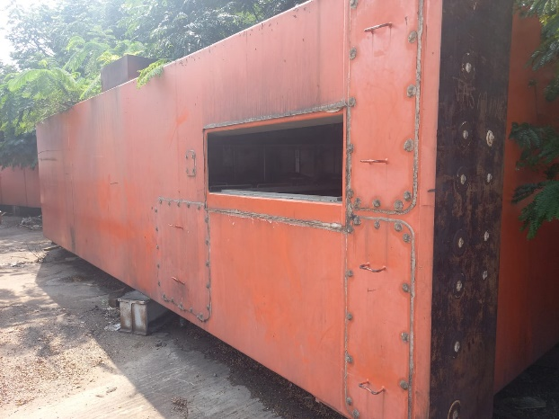

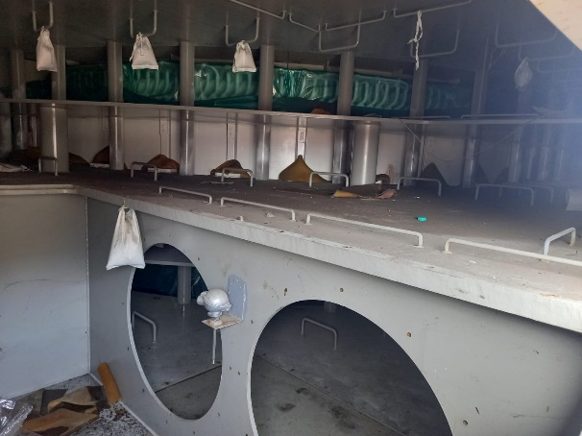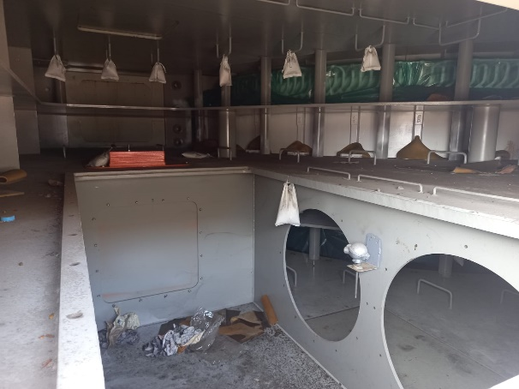

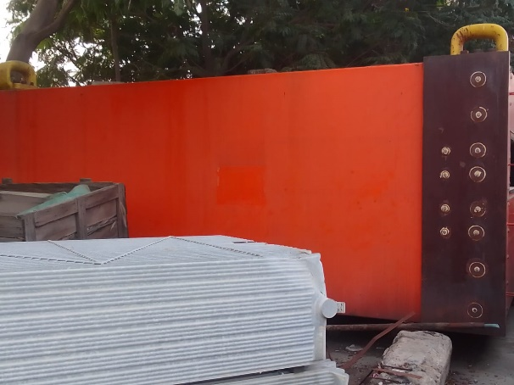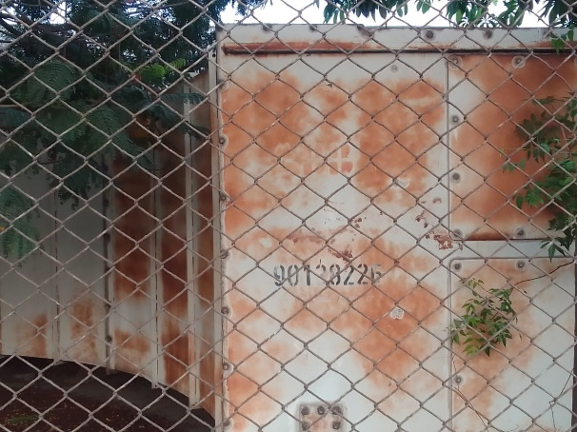
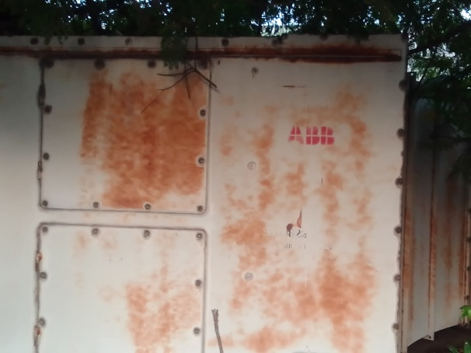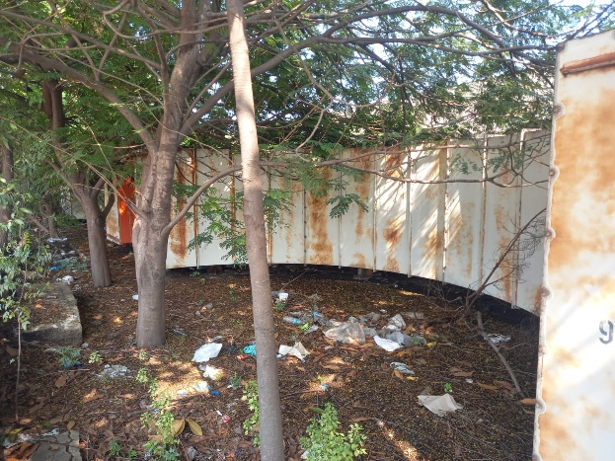

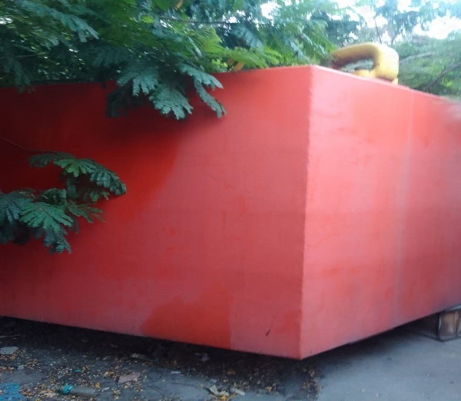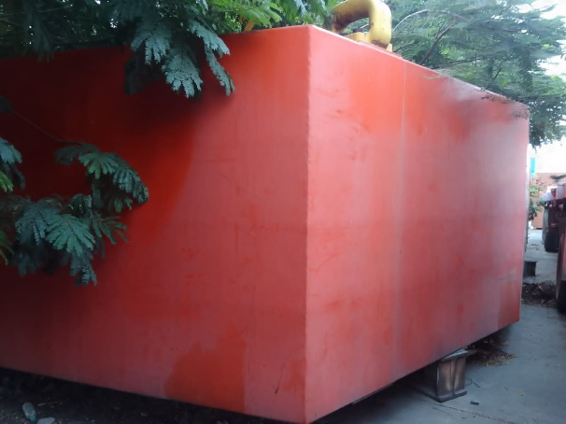

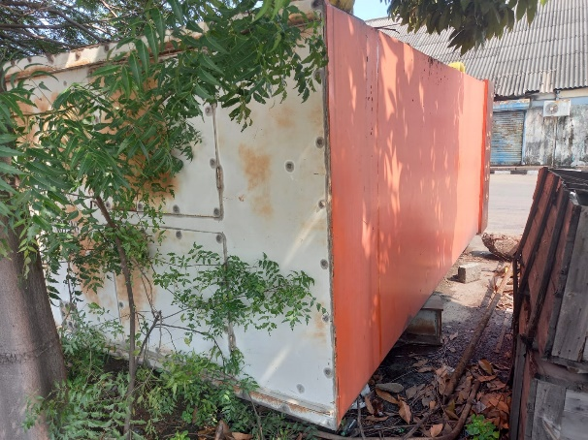

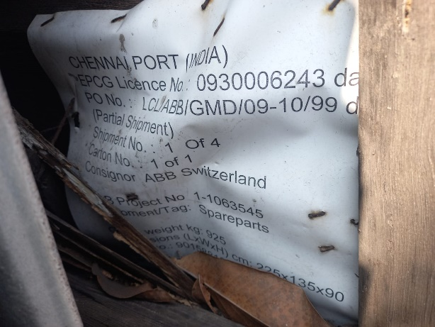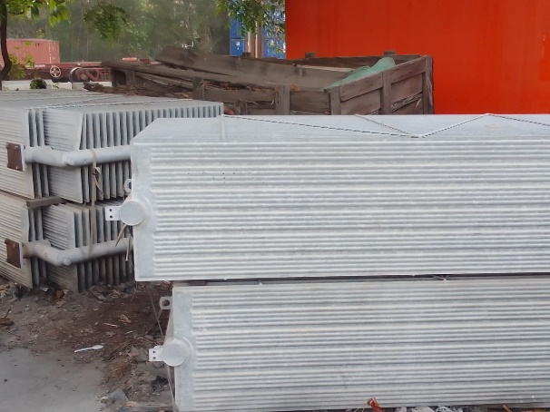
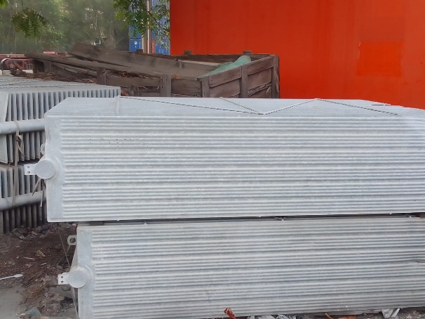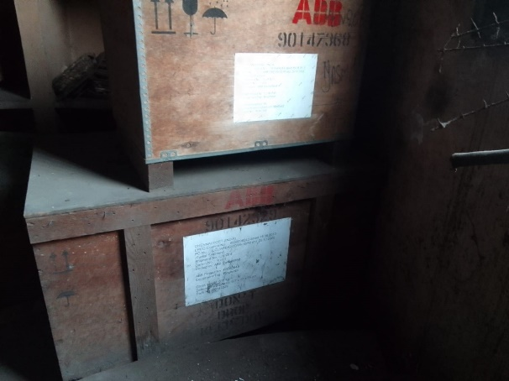

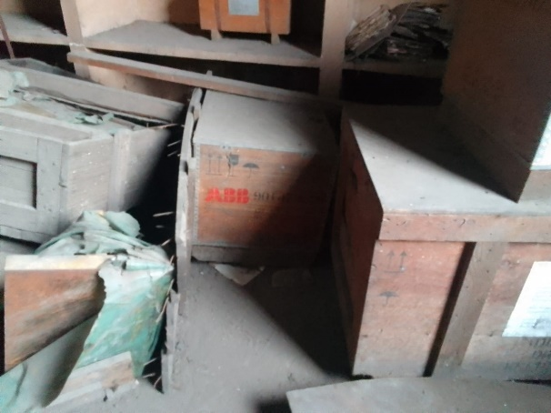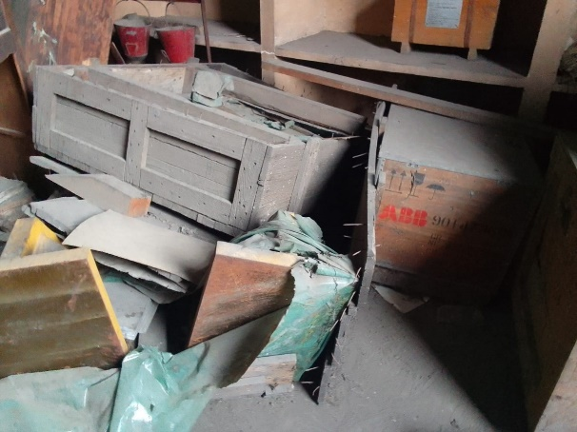

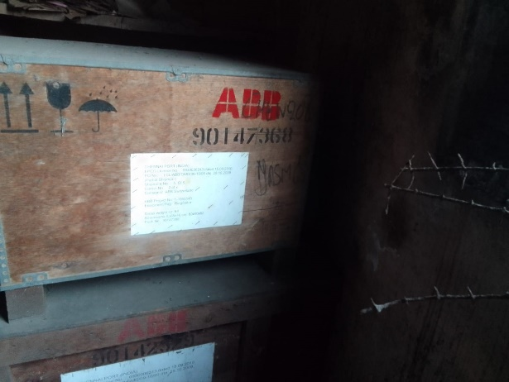

CONDITIONS OF SALE

- Lots to be examined by the intending purchaser before bidding and to be taken with all faults and errors of description.

- The goods are to be taken on ‘AS IS WHERE IS’ basis. The Chennai Port Authority (ChPA) shall not take the responsibility with reference to Weights, Measurements, Quantities, Qualities, etc.,

- E-Auction will be conducted online by the Chennai Port Authority’s Auctioneer, M/s. MSTC Limited, Southern Regional Office, ISPAT BHAVAN, 3rd Floor, No.5, Kodambakkam High Road, Chennai – 600 034, through their website www.mstcecommerce.com.

- Buyers who wish to bid in the E-Auction shall remit pre bid EMD as mentioned in each lots by way of NEFT/RTGS mode through pay pre bid EMD mode from the web site www.mstcecommerce.com to participate in the E-Auction.

- The pre bid EMD of the unsuccessful bidder will be refunded back after completion of E-Auction by the Auctioneer to the respective bidders Account Ledger. Chennai Port Authority (ChPA) will not pay any interest to the bidder on the pre bid EMD amount/Balance amount/Refund amount or any deposits.

- The highest bidder to be the purchaser and in the event of any dispute arising between two or more bidders, the lots so disputed should be put up again and resold.

- The bid amount shall be paid in full, immediately after the bid is knocked down. If this not possible, the full payment / balance amount should be paid to the Chennai Port Authority’s Financial Adviser and Chief Accounts Officer on or before 4.00 p.m. on the third day, calculating from the date of confirmation of sale, failing which the amount paid will be forfeited and the Chennai Port Authority will resell the lot either privately or by Public Auction or E-Auction at the risk and responsibility of the defaulters.

- Goods advertised for sale will not be withdrawn by the Chennai Port Authority, except on payment of sufficient deposit to cover the Harbour dues, Demurrage charges and other charges due thereon.

- The goods sold in Auction will not be delivered to the purchaser unless the purchaser produces Delivery Order from the Auctioneers for having paid the amount in full. Also the bidder should complete the Customs formalities, such as payment of Customs duty, if any.

- Goods sold in Auction shall be allowed seven free days from the date of confirmation of sale, excluding Customs notified holidays and closed holidays declared by the Port and thereafter applicable Port charges at daily rates as per Scale of Rates shall be charged, up to and including the date of clearance.

- Within the free period, the bidder shall collect Bills of Entry with assessed Customs duty amount from the ChPA and remit the same to Customs with proper receipt.

- The lots sold will be lying at the risk of the purchaser and must be removed within the free period of seven working days from the date of confirmation of sale at the purchaser’s expenses.

- The purchasers are distinctly warned that if the goods are not cleared within eight days from the date of expiry of free period, the sale of lot shall stand cancelled and the EMD / Bid amount will be forfeited. The bidder will have no claim whatsoever over the material and the same will be sold either privately or by Public Auction or E-Auction. The first purchaser will in such a situation be held liable for any loss arising from such resale and will forfeit any advances together with auctioneer’s commission.

- The Chennai Port Authority shall reserve the right to withdraw any of the items notified for sale without assigning any reason for such withdrawals. However, if any payment has been made, it would be refunded.

- The Chennai Port Authority shall reserve the right to take such action against the defaulting bidder as deemed fit by the Trust and/or can debar the said bidder from bidding in the current and/or future auctions also.

- The bidders shall gain admission into the Harbour on days of inspection to inspect the materials. The bidders may obtain necessary Harbour Entry Permits through on line, only on payment basis as per Conditions, stated as below; -
CONDITION: Inspection by Bidders– Any of the Bidders or their authorised representatives may inspect the goods offered before quoting and the same can be done during working hours, before auction, as per the inspection schedule specified in the auction catalogue. Temporary passes required for entering the Harbour for inspection of the goods offered can be obtained only through on line, on payment basis for which the bidder should submit the details to Commercial Division/ Traffic Dept., by a Letter or e-mail (dtmc@chennaiport.gov.in) for requisition of Harbour Entry Permit(HEP) well in advance such as i) Firm’s Name ii) Mobile No., iii) e-mail address, iv) Purpose with Chennai Port Authority’s Reference of e-auction/Delivery order etc. v) HEP for No. of Persons / Vehicles/Drivers. On receipt of above details, Commercial Division/Traffic dept., will forward the request for Harbour Entry Permit to Chennai Port Authority Pass section. Pass section will process and a message with a link and Gate Pass-id will be sent to bidder’s registered e-mail automatically. By using the link received, the requisite documents are to be scanned and uploaded duly entering the date of HEPs required with No. of Persons/vehicles/Drivers and making necessary payment. After processing the request, approval message will be sent again to firm’s e-mail address from Traffic Manager (Pass Section). Again the link in your e-mail may be utilized for taking print-out copy of Harbour Entry Permit with QR Code for entering inside Harbour premises.
The successful bidder should also obtain HEP on payment for clearing the goods.

- The delivery of the lots would be allowed from 1000 Hrs. to 1300 Hrs. and 1400 Hrs to 1700 Hrs. only.

- The GST and Income Tax as applicable will be levied additionally as per rules in force.

- Terms: ECS/RTGS/Online payment thro’ any Nationalized Bank.

- All the lots sold in the auction are subject to confirmation.

- If any packages are not sold in the auction for which they are listed, they will be included for sale on the succeeding sale by Tender or in Public Auction.

- The Chennai Port Authority reserves the right to amend and modify ‘Terms and Conditions’ and announce the same if need be while the auction is in progress or prior to commencement of Auction.

Sd./-
Chennai-600 001 TRAFFIC MANAGER
JUNE 2023 Chennai Port Authority

